USER GUIDE

1.0 Creating Web Pages

1.1 Levels

Every SiteApex website is constructed in a hierarchy with Sections (top level), Categories, and Pages (bottom level). Each type of webpage has similar features available to them. Using a hierarchy allows you to organize your website into a clearly defined structure so both you and your visitors will find information faster.

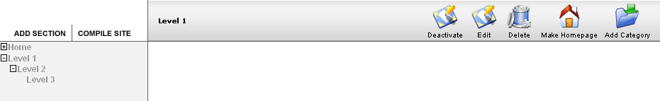
Controls
Site Map
Current Page

The sample screenshot above shows all three levels, which are indented for clarity
- Level 1 is a Section
- Level 2 is a Category
- Level 3 is a Page

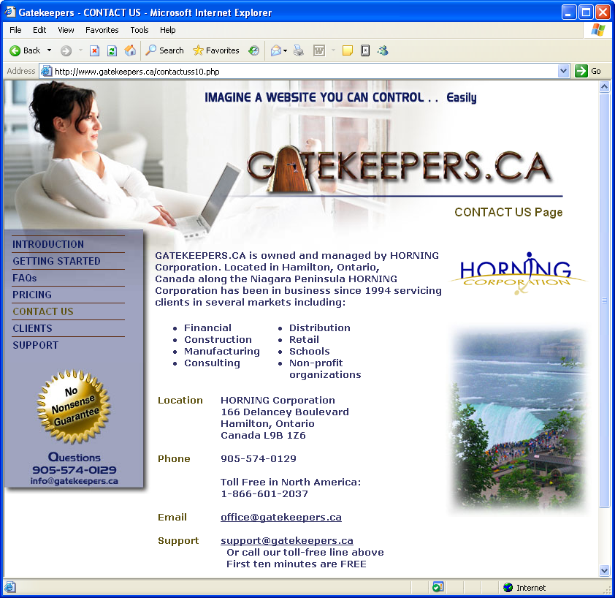
Clicking on the plus sign beside a Section title opens a list of Categories. Clicking on the plus sign beside a Category title opens a list of Pages. To close a Category or Section list, click on the minus sign. Clicking on the actual Section, Category, or Page title opens the webpage Controls. To view the Options available for controlling your webpages, click on either the Edit or the Add Controls. This manual focuses on explaining many of the Controls and Options found in SiteApex.

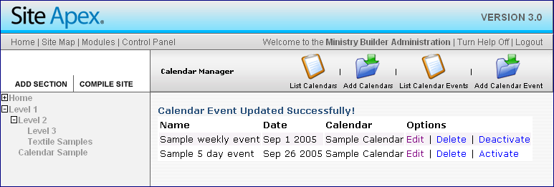
NOTE: The word “Visitor” used throughout this document refers to any person visiting your website. The word “webpage” refers to any page your visitor will see while visiting your website. The capitalized word “Page” refers to a level in the website hierarchy structure as illustrated above.
1.2 Modules

By activating some of the modules (point 2.0) listed you will have the choice of creating a specific type of webpage. Each module has its own unique functions for enhancing your website and the experience of your visitors.
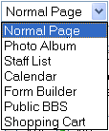
- Normal: standard webpage with content (point 1.4).
- Photo Album: inserts a template for displaying an album module (point 3.0).
- Staff List: inserts a template suitable for staff photos and contact information.
- Calendar: inserts calendar template module (point 4.0) with navigation buttons for choosing different months of the year.
- Form Builder: allows you to insert forms created with the form builder module (point 5.0).
- Public BBS: inserts a Bulletin Board Service module similar to a chat room.
- Shopping Cart: inserts an advanced e-commerce store. This is only available if you have purchased our shopping cart module.

Each module is unique and must be activated first, either by creating it or having us install it for you. For example, if you want a photo album of pictures, you must first create a Photo Album in the Photo Album module. If you want a Shopping Cart, you must first call us to install and configure this module for you.

1.3 Page Controls
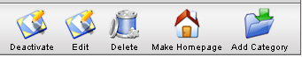
(Sample above is shown when in a Section)
1.3.1 De-Activate: Removes a webpage from the menu navigation but does not delete it. This control is useful for webpages that are time sensitive such as; seasonal, holiday and special events which may be used again in the future.

1.3.2 Edit: Takes you to a new screen allowing you to manage the webpage characteristics and content.

1.3.3 Delete: Deletes the webpage completely. If it is a Section or a Category, it will also delete the webpages under it.

1.3.4 Make Homepage: Turns the webpage into your website’s homepage (index.php) which is the first page visitors will see when arriving at your website. Any page can be made into a homepage at any time.

NOTE: If you make a Section called “Home” and designate another webpage with the “Make Homepage” control, you will essentially have two pages acting as homepages which can cause confusion. If you want to use this control, do not call any Sections “Home”.
1.3.5 Add Category/Page: Allows you to add a Category webpage if you are in a Section or allows you to add a Page webpage if you are in a Category. For Options see point 1.4

1.4 Page Options

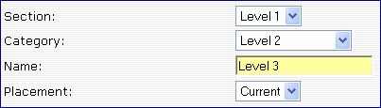
1.4.1 Navigation Hierarchy: All webpages can be reorganized using the drop down list as shown (right). Categories can be moved to other Sections, and Pages can be easily moved to other Categories.

NOTE: Once a webpage has been created as a Section, Category, or Page you can not change its designation. For example: A Page can not become a Category and a Section can not become a Page, etc.

1.4.2 Placement: This feature allows you to position the Section, Category or Page anywhere in the list of webpages for that area of your website.

1.4.3 Description: The information you type into this editor window will not be displayed in your final webpage. Use this window as a scratch pad to keep ideas or instructions for what to include or not to include on each particular webpage.

1.4.4 Type of Page: This option allows you to choose the standard type of page called “Normal Page” or a page based on on a module (point 1.2).


NOTE: Whatever type of page you choose here will determine how your page will be created and what set of Options will follow.

1.4.5 Template: If you have purchased different template designs they will be available for you to choose in this drop down list. You can change the template at any time by simply choosing a new template name. Once a new template is chosen the content for that particular webpage will be automatically inserted into it.
1.4.6 Menu Images: This option allows you to use graphics instead of text in your navigation menu. So instead of your navigation menu looking like the text sample below, it could look like the graphical sample buttons which can have an animation rollover effect. Text rollover effects are limited.

 |  | OR |  | 
Text | Rollover Effect  (Turns Yellow) |  | Graphic | Rollover Effect  (incl. animation)

1.4.7 Downloadable Files: A list of files will be visible just under the above set of options if you have uploaded files for your visitors to download. Look at the “Manage Files” (point 7.0) module to understand how to upload files. Once the files are uploaded into the file categories that you have created, the file category headings are shown on the left and the list of files in that category are shown on the right.
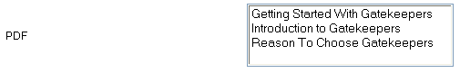
File Category Files

In the example above the “PDF” category contains three files to choose from. Each category is listed separately on every Edit page so you can choose to add any file into any webpage. Each chosen file will display at the bottom of your webpage (point 7.0).

1.4.8 Reference pages: This option allows you to disconnect your webpage from the navigation menu, which essentially “hides” the webpage from your visitors. The only way to access this webpage is through a hyperlink from another webpage or in an email.
This option is especially useful for two reasons:
- If you want to simplify the number of webpages in your menu navigation you can turn non-essential webpages into reference pages and access them with hyperlinks. An example of this is a Privacy Policy or Warranty Policy webpage.
- If you want to have non-public webpages with specific confidential information for certain viewers that you will reference in an email with a hyperlink.

1.4.9 Security: You have the option of assigning security to any webpage by clicking “Yes” on this option (point 6.0). However, for anyone to view this webpage you still need to assign a “Secure Group” (1c below). For a visitor to gain access to this webpage they will have to login first.

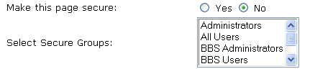
1c
1.4.10 Submit: The “Submit” button also acts as a “Save” button. By clicking “Submit” you are uploading your changes to the website.
SAVE

NOTE: The webserver which hosts your website will timeout (disconnect) your SiteApex session if your connection is inactive for more then a certain period of time. Webservers only know if you are still connected to them when you make a request, such as asking to view another screen or when you “Submit” changes. We therefore advise you to submit your edit changes every 20 minutes. Potential loss of content will only affect the screen you are currently working on. All other changes previously submitted are safe. You will know immediately that you have lost connection when you try to “Submit” or move to another screen and you have to login again.

2.0 Module Overview
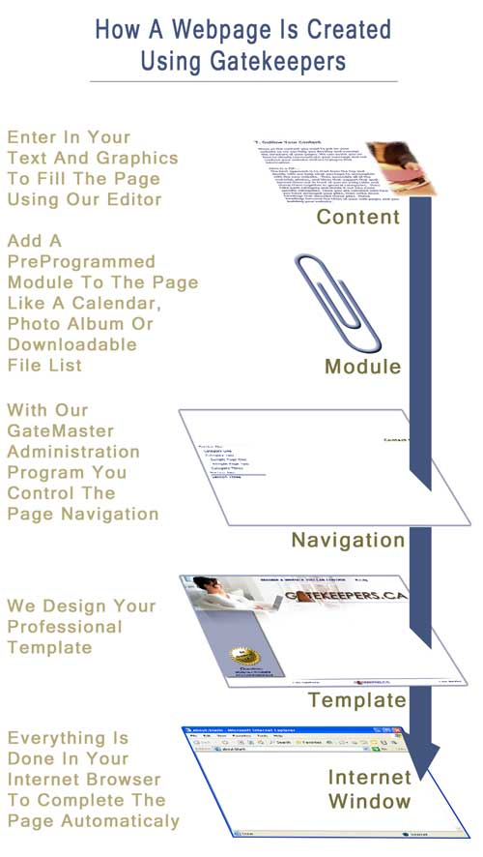
2.1 Modules: We offer a variety of useful modules to enhance your website. This manual will guide you through the features and functions of the most popular ones. Most modules will require that you first set them up before webpages can access their features. As an example, you must first create a photo album in the Photo Album module and then you can create a webpage for your album. Some modules like the Forms module have many different uses which can not all be explored in this manual. As a result we focus on the Controls and Options of each module and will let you discover how to put them to use for your specific needs. We do, however, offer training for some specific uses such as Registration Forms.

2.2 Module Definition: A module is a pre-programmed package of software code that can be inserted into a webpage using our SiteApex Administration Tool. Modules are composed of templates and/or functions for you to use when building your website. Some modules like the Shopping Cart are priced separately.

2.3 Deactivate Control: Several lists give you the Control to deactivate an item so it is not visible to your website visitors. The item is not deleted, so you are able to activate it again later. Once you publish (compile) the website, the items are deactivated for you. This allows you to design time sensitive webpages and reuse them again when needed. If someone were to add a deactivated page to their favourites list, the page will still be available as long as it is not deleted or renamed.

2.4 Active Option: Since some items are immediately visible to your visitors without the need to publish (compile) the website, we have given you the option of activating or deactivating the item while creating it. These include items such as photos and calendar events.
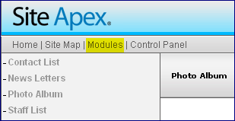
2.5 Available Modules: We are updating and adding new modules all the time. Visit our website to view the latest additions and enhancements. You can also email us if you do not see a module you require.

3.0 Photo Album Module

3.1 Photo Album Controls

The photo album module allows you to upload photos into the albums you create, so your visitors can view thumbnail images first and then click on these to view the larger sized photo. All photos must be in the standard “jpg” format.

NOTE: To make use of these albums effectively you must first resize your photos to display properly on computer monitors. Digital cameras save photos that are suitable for printing but are often too large for displaying on a screen. There are many photo software packages available which allow you to resize your photos to be “web friendly”. We can recommend some if you do not already have one.

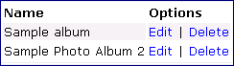
3.1.1 List Photo Albums: This provides you with a list of the albums you have created and some controls for managing them.

3.1.2 Add Photo Album: You must create a Photo Album before you can upload pictures. Once the album is created you can then add the webpage it will be placed into. You can add your photos to the album later. When created the album you have the option of including a background image behind the thumbnails preview photos. If your thumbnails are preprogrammed to be a certain pixel size, then your background image should not be much larger (10 to 20 pixels). Each photo will overlap your background image from the center.
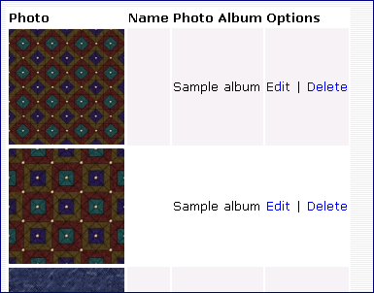

3.1.3 List Photo Albums Photos: This provides you with a list of photos inside any of the albums you have created and some controls for managing them (3a). You can Edit the photo which allows you to change the information in point 3.2.1, or delete the photo. You will not have to browse for and upload the photo again unless you want to change the actual photo.
3a

3.1.4 Add Photo Album Photos: See point 3.2

3.2 Add Photo Album Options

3.2.1 Add Photo: Once an album is created for your photos you can use this control to insert your photos into it.

Album: Choose an album from the dropdown list in which you will insert the photo into.

Photo Name: Optional - You can give your photo a short descriptive name which will show up under the photo. This option is often not used.

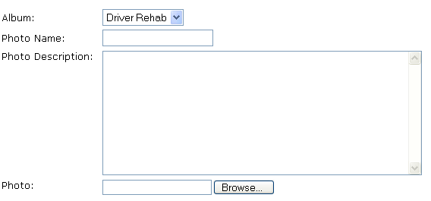
Photo Description: Optional – Use this comment box to describe the photo or give instructions on how to use or not use the photo.
3b

Photo: Click on the “Browse” button (3b) to find the photo on your own computer or on your local network drive, if you have one.

NOTE: Don’t be surprised when you click Edit and see the photo information you entered but there is no file path beside the “Browse” button. Since the photo is already uploaded there is no need to display the file path. If, however, you want to keep the same description but replace the photo, click on “Browse” and find the new photo on your computer or network drive.

NOTE: All photos must be in the “jpg” format which most digital cameras use.

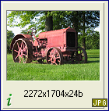
NOTE: Resizing photos so they are ‘web-friendly’ is necessary before uploading to your website. Images can not be copied to your website like other windows programs can copy to each other using drag-and-drop or the cut/copy and paste functions. Instead you must first upload images to the webserver using the Add Photo control. However, if you do not resize them first, the upload can take a long time and your visitors will not be too happy when they try to view the oversized photo.

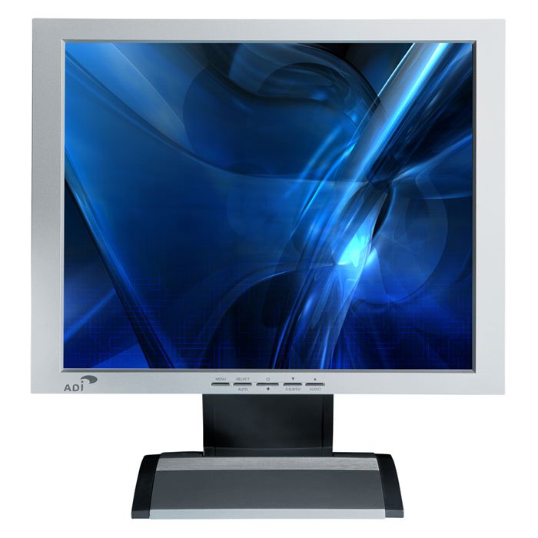

Resize First: Before uploading an image it needs to be made “web-friendly”, which means the resolution has to be small enough for a computer screen. Notice in example (4a) the thumbnail view of this image is reporting that the resolution is 2272x1704 (pixels). Since most monitors can only display 800 pixels wide without scrolling, only the top left corner can be seen. The actual image is suitable for printing but not for computer screens as shown in (4b). The image is too large to display on a webpage and must be made smaller with a program like FocusViewer or Adobe Photoshop Elements.
4a
4b

Why Resize: The reason you want to resize photos before uploading them is because webpages resize images after your visitor has downloaded the actual larger file size first. Since most websites offer you a content area of between 500 and 700 pixels wide due to navigation menus, you need photos that are smaller than this. Width is more important than height because visitors will expect to scroll vertically but they get frustrated scrolling horizontally (left and right) too.

4.0 Calendars Module

4.1 Calendar Controls

The Calendar Module allows you to add as many different calendars as you need. You can have a separate calendar for each department, committee, team, or any other category within your organization. Each calendar will list unique events for any day of the month. Calendars currently do not share events. If you need to share events you are better to have a common calendar.

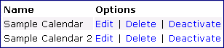
4.1.1 List Calendars, Add Calendar: Same as listing and adding a Photo Album (refer to point 3.1).

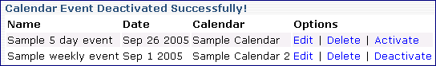
4.1.2 List Calendar Events: All the events are displayed in the list which allows you to Edit, Delete, or Deactivate each one individually. Once deactivated the control changes to the word ‘Activate’ (4a) so you can reactivate it again. You will also see a ‘success’ alert just above the list after Activating or Deactivating an event.
4a
4.1.3 Add Event: See point 4.2.

4.2 Add Calendar Event Options
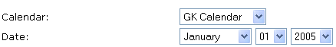
4.2.1 Calendar: Choose which calendar the event should appear in.

4.2.2 Date: Choose the start date of the event.
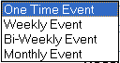
4.2.3 Recurrence: If the event occurs once then choose “One Time Event” and set the Duration to “1” (point 4.2.4). If it occurs for more than once, set the reoccurrence to daily (One Time Event), Weekly, Bi-Weekly, or Monthly and then set the Duration to “2” or more.

4.2.4 Duration: This option is used to set the number of Reoccurrences an event will last (point 4.2.3). If it is a weekly event for one year, set the Recurrence to “Weekly Event” and the Duration to “52”.

4.2.5 Event Name: Allows you to give the event a name (4b) that will show up in the calendar for each day the event occurs.
4c
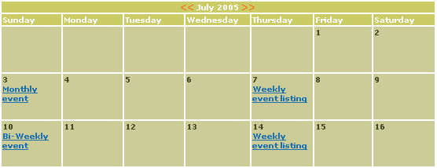
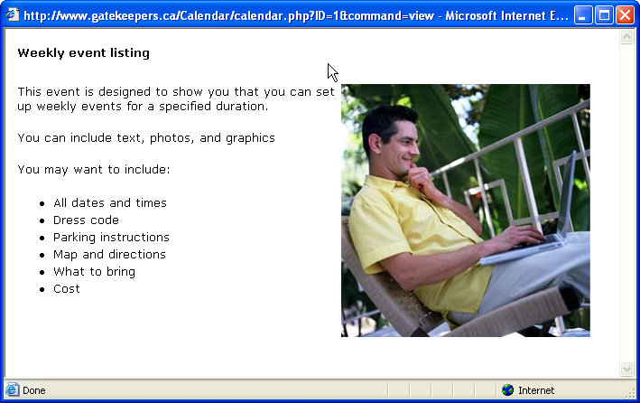
4b
The events shown in the above calendar are hyperlinks which, when clicked on by a visitor, open an event window displaying the event description. This window can show text, photos, maps, email links, and other hyperlinks.

4.2.6 Description: Allows you to input content that will display in the hyperlink window (4c) when someone clicks on the event. When entering content for this event window, consider answering the following questions your visitor will likely be looking for depending on the event:

- Event Name  - Date(s), Time(s)  - Inclusions and Exclusions  - Location  - Directions  - Graphic Map or Link to Map  - Parking Service and Cost  - Registration Deadlines  - Seminars/Speakers/Classes  - Admission Cost  - Payment Methods  - Attire |  | - Transportation  - Accommodations  - Services Available  - Handicap Access  - Contact Person(s)  - Contact Email(s)  - Website(s)  - What To Bring  - What Not To Bring  - Menu(s)  - Diet and Allergy Provisions  - Other Instructions

4.2.7 Active: See point 2.4
5.0 Forms Module

5.1 Designing Your Form

Forms can be used for a variety of purposes. As a result they have several options which makes them appear to be more complicated to set up. We have pre-designed some standard form options to reduce this complication. If you have a need beyond the capabilities we have designed, let us know and we can enhance the Form Builder to suit your needs. Some forms require secure access, so it is important to also read about the Security Module (point 6.0).
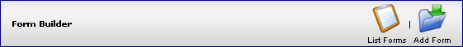

NOTE: Once a form has been created you can not change any of the fields. So carefully plan out what the form will look like before you start building it with this module.

5.2 Form Controls

5.2.1 List Forms: This option is covered in point 5.6.

5.2.2 Add Form: Allows you to begin creating a form. After creating a form you must insert it into a page where it can be viewed and used. See point 5.3

5.3 Add Form Options

5.3.1 Form Name: Give your form a short descriptive name so you will recognize its purpose later. The form name is not displayed on the website.

5.3.2 Form Description: Allows you to add comments about your form. It is also not displayed on the website.

5.3.3 Introduction: This is the opening comments introducing your form to your website visitors. Since the actual form will appear just below the introduction, you may want to include instructions on how to use the form and answer any questions they may have when filling it out.
We suggest you answer the following potential questions:
- Clarify who should fill out and submit the form.
- Explain what happens to the information they input.
- Offer them a “Privacy Policy”.
- Give them a timeframe of how long it will take to process the form.
- Tell them if they will receive a response and what it will be.
- Explain what they are to do if further action is required.

Some of these above answers can be included on the “Thank You” webpages described in point 5.3.4.
5.3.4 Thank You's: After a visitor completes your form and submits it, they will automatically be taken to a “Thank You” webpage.

- No Payment webpage: If this form is not being used as a method for receiving payment then use this Editor window.

- Paid by Cheque webpage: If this form is to be used for receiving a cheque payment then use this Editor window to give them further instructions.

- Paid by Paypal webpage: If this form is to be used to receive a payment and you have already set up a Paypal account which accepts credit cards then you can use this Editor window.

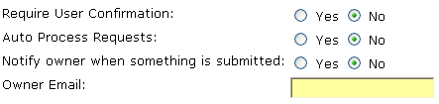
5.3.5 Require User Confirmation: This feature sends the visitor a “confirmation” email after they complete the form. They will be asked to click on a “confirm” link to validate their email address (point 5.6.1). If you use this feature and they do not confirm their email, their form submission will not be visible to you. Using this feature eliminates most pranks and uncommitted visitors from submitting a form.

5.3.6 Auto Process Requests: Answering “No” to this feature gives you an opportunity to process forms manually. This means that when a form is submitted you have the opportunity to examine the person’s request before considering it “processed”. It makes no difference to the system if you manually or automatically process forms. This feature’s only purpose is to offer you a method for managing your forms.

Consider the familiar inbox and outbox scenario often found on many people’s desks. Requests are received by the inbox and once they are acted on — or processed — in some way the requests are moved to the outbox.

When to choose “Yes” or “No” to Auto Process …


Unprocessed
“Inbox”
Choosing “No” to Auto Process means each form submission will be visually checked, validated, and acted on in some way by an administrator, just like the familiar inbox and outbox idea suggests.
Processed
“Outbox”

Choosing “Yes” to auto process means each form is moved immediately to the outbox with no administrator checking, and if the form was associated to a secure group the person becomes a secure user immediately.
Each example below illustrates different levels of validation you can include when designing a form. This assumes the form is associated to a specific Secure Group (point 5.3.9). You can create several levels of security for your website.

Example for designing a LOW security validation form:
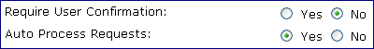
No valid information required:
There is no email confirmation required and this form will process automatically. The reason this is considered low security is because there is no visual validation by an administrator and the system will make them a secure user automatically if the form had a security association.

Example for designing a MEDIUM security validation form:
Only a valid email address is required:
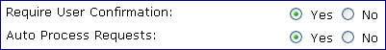
The only intervention required to complete this form registration process, is that the visitor must confirm by entering a valid email address. This will send them the webserver’s confirmation email which they must then click on the “confirm” hyperlink (point 5.6.1). The reason this is considered medium security is because there is no visual validation by an administrator and the system will make them a secure user automatically once they confirm the email.

Example for designing a HIGH security validation form:
A valid email address and valid information is required:
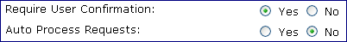
To complete this form registration process the visitor must confirm by entering a valid email address and by entering valid information for all questions (called fields) like their name and address. The reason this is considered high security is because the webserver will require them to confirm and the administrator will visually have to look at each request before making them a valid secure user.

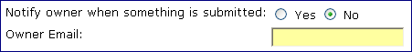
5.3.7 Notify Owner:
This option tells the program to notify by email the person whose email address is entered. Whenever a form is submitted, whether it is confirmed or not, the “owner” will be notified. The “Owner email” does not have to be an administrator’s.
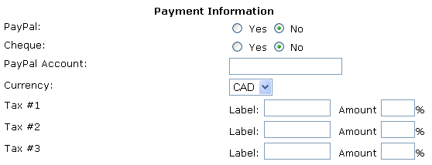
5.3.8 Payment Information: These options are self-explanatory. You can designate the Tax “Label” as anything understandable to your visitors.

5.3.9 Associate to groups: This option allows you to designate which security group your visitors will become part of once the form is processed.
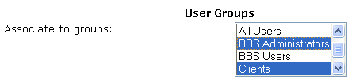
NOTE: To choose more than one security group you hold down your CTRL key on your keyboard and Left click the security groups you want.

5.3.10 Form Fields: Answering “Yes” in the Collect column will display the questions in your form. Answering “Yes” in the Required column will not let the visitor submit the form unless every required question is answered.

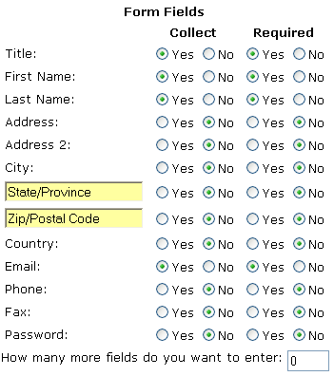
There is always a question as to why we include two address fields called “Address” and “Address 2”. The reason is to give the visitor the option of inserting their suite or apartment number.

There are two options which allow you to change the wording being displayed in your form. They are the State/Province field and the Zip/Postal Code field. If all your visitors who will be filling out the form are Canadian, then you would want to remove the “State” and “Zip” fields.

5.3.11 More Fields: Before clicking “Submit” you can request that more question fields be added to your form, in addition to those shown here. Before the program can give you more fields it needs to know how many more you need.

NOTE: Once you insert a number and “Submit” you can not change your form without loosing your additional questions you may have setup.

5.4 Additional Form Questions

5.4.1 Name: Insert the question you want to ask of your visitor.

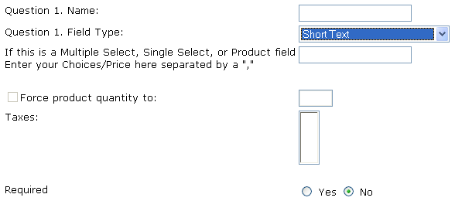
5.4.2 Field Type: Provides you with several options for the type of questions you can ask your visitor to answer. Carefully consider this option keeping in mind how your visitors may be forced to answer your questions.

Short Text: A very short answer needing only one line of text.

Long Text: A longer answer needing several lines of text, also referred to as a “Comment” box.
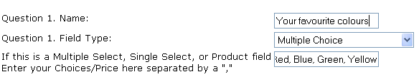
Multiple Choice: Your visitor can select more than one answer if this option is used. You control the answers they can pick by inputting them in the Multiple Select row (5a). This option will look like this to the visitor who is filling out your form.
5a

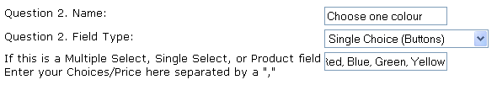
Single Choice buttons: Your visitor can select only one answer and you control the answers by inputting them in the Multiple Select row (5b). This option will look like this to the visitor who is filling out your form.

Single Choice list: Your visitor can select only one answer and you control the answers by inputting them in the Multiple Select row. This option will be a dropdown list that expands when they click on this button.
5b

Other List: Same as the Single Choice list above except the visitor has the option of choosing “other” which allows them to enter in their own answer below the question.

User Entered Payment Field: Allows the visitor to enter in the amount they will pay rather than you setting an amount. Especially useful for situations where you offer bids or partial payments.

Product Field: When offering products or services that visitors can purchase, this field type allows you to enter in; the name of the product or service, the minimum quantity, and taxes applied.
5.5 Installing Your Form

Before you can use your form you must first insert it into a webpage that you will now create with the following steps.

STEP 1: You must first add a page. (point 1.3.5). Then choose the “Form Builder” option (5c) to determine the format of webpage you are adding (point 1.2).
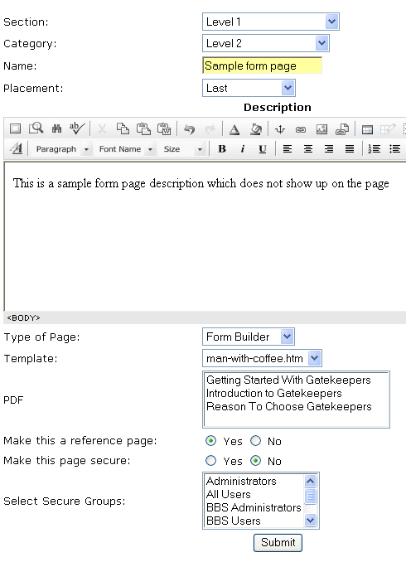
5c

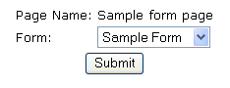
STEP 2: After clicking “Submit” on the screen shown above, you will then be asked which form you want to include on the new webpage. Once you click “Submit” on this second screen, your form is inserted and ready to use.

Step 3: Check your form to make sure it is functioning properly. See the next page to view our sample form before any information has been added by a visitor. If you do not like the font or colour of your form, contact us and we will give you a cost to alter it to suit your needs.

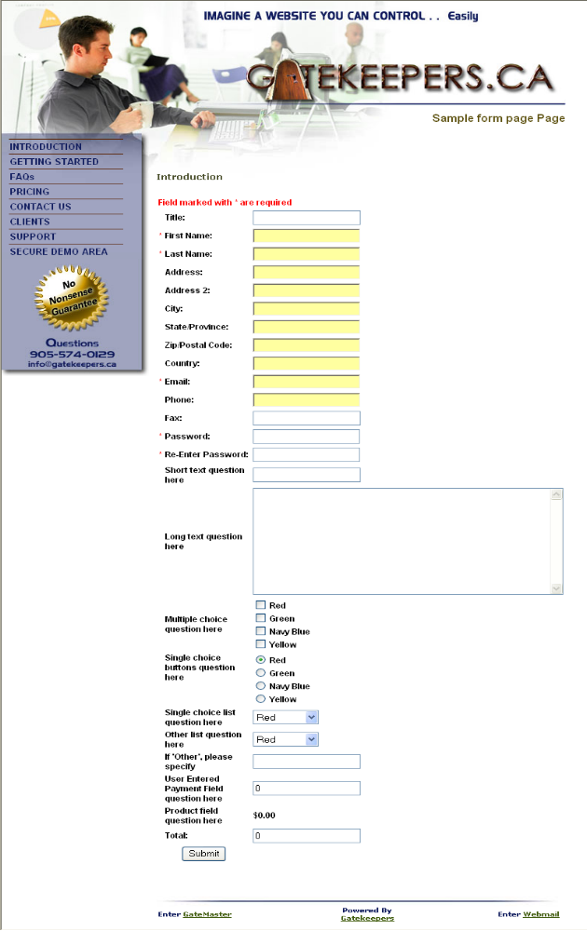
5.6 Processing Forms

After you complete your form and the page which displays the form on your website, visitors may begin using it. The question of what happens next depends on how you initially set up your form. We will highlight below some of the events that could happen depending on how you setup your form (point 5.3)

5.6.1 Confirmation Email: If when you set up the form you requested that the user confirm their submission, then an email will be sent to their email account asking them to “confirm” the information they entered. Once they click on the “Confirm Now” (5d) link in their email, the form request will become visible to you in the database.
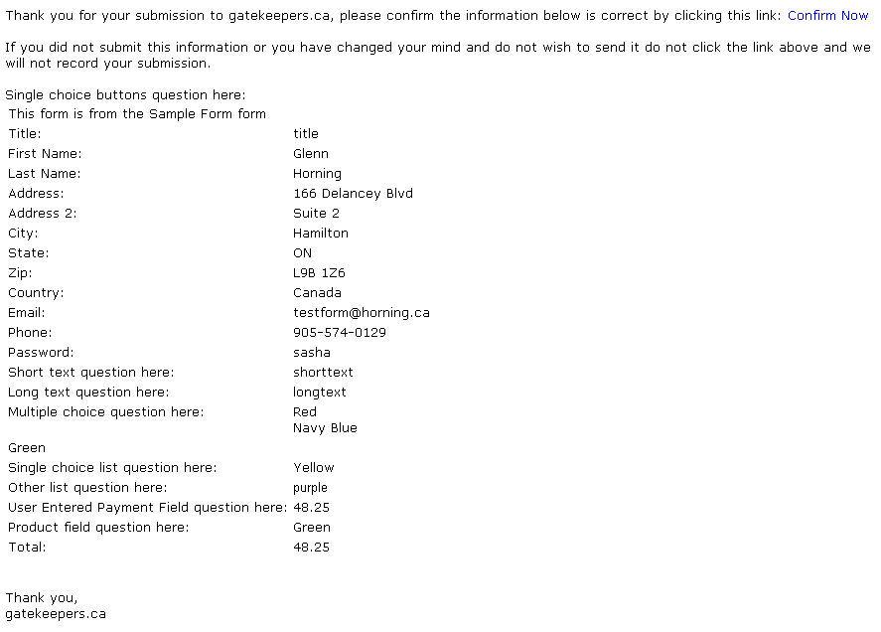
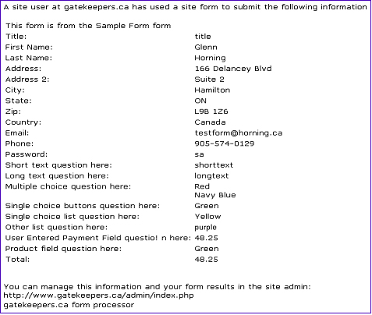
5d
5e

5.6.2 Notification Email: If you included an “Owner email” then at the same time as the above is happening, the owner of the form is receiving an email notification (5e) that a form has been submitted. Included in this email is all of the information the visitor submitted.

5.6.3 View Forms: This page control shows you a list of forms you have created.

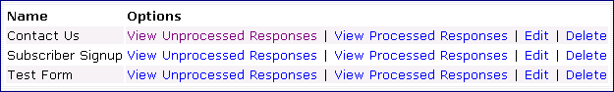
Clicking the List Forms control will take you to a list of forms shown below. The View Unprocessed Responses control allows you to view submissions (responses) in the database which still need processing. The View Processed Responses control allow you to review submissions. You also have the control of Editing submissions and Deleting them completely.

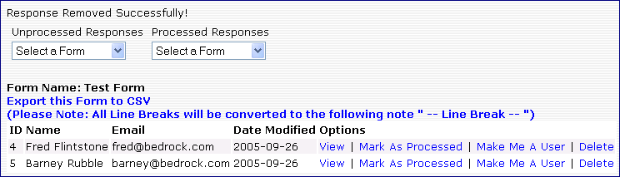
5.6.4 View (Processed or Unprocessed)Responses: This control allows you to view form submissions (responses). This opens up a few more options which are listed below. We have included the “Export this Form to CSV” feature, which allows you to create a file of submissions (responses) in a format that MS Excel and other spreadsheet programs can read and manipulate into charts and graphs.

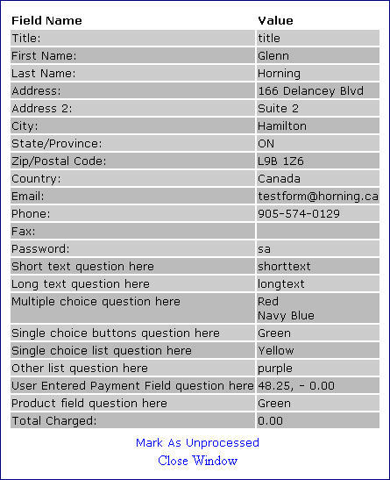
View: Allows you to view all of the fields (answers) the visitor entered when filling out your form (5f).
5f
Mark As Processed (or Unprocessed): Clicking this option will processes the request (submission) which moves it to the “Processed Responses” list. Once moved, you can move it back to the “Unprocessed Responses” list by clicking the link as shown.

Make Me A User: If the form was associated to one or more Secure Groups (point 5.3.9) then clicking this link moves them to the Security module and alters their status to “user” where they can be given various privileges.
5f
Delete: Once deleted the person’s form request (submission) is no longer in the system.

6.0 Security Module

6.1 Security Group Controls

Security controls are found by clicking the ‘Control Panel’ menu item and then clicking ‘Security’.
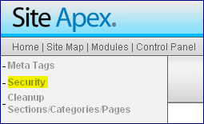
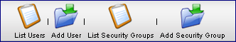
NOTE: Security is assigned to the “Group” and not to the individual “User”. Once a User is assigned to a Secure Group they are given the security privileges of that group. An individual User can belong to more than one Secure Group and thus have privileges of all the Secure Groups they belong to.

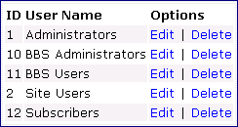
6.1.1 List Security Groups: Shows you the list of security groups you have created. We have installed some default groups to get you started. You must first create a Secure Group before you can add Users (members). Click on the Add Group link to create additional groups.
6a

6.2 Add Security Group Options
Hold down CTRL key and left click to choose multiple items.
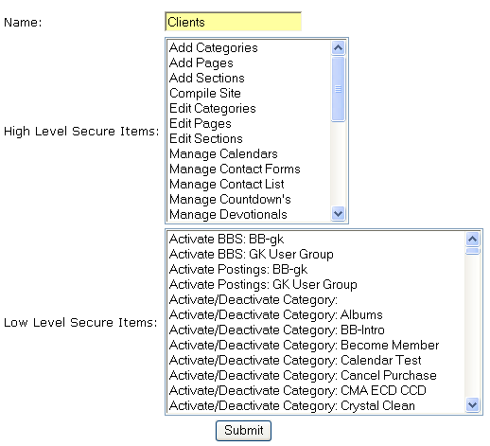
Privileges are divided into two categories: High and Low. This division of privileges helps the administrator understand the scope of the privilege when assigning items. High-level items apply to the whole website. Low-level items apply only to the specific area (webpage, function, etc.) shown.

Assigning low-level items enables the administrator to assign restricted privileges to very specific areas of the website. For example, one group could be assigned the privilege of editing only one page of the website and nothing more.

6.2.1 Add/Edit: (6a) This option allows the administrator to assign whatever privileges they want to whatever group they want.

6.3 Security User Controls

6.3.1 View Users: Shows you a list of Users in each Secure Group. You can also add a new group here by clicking on the “Add User” link. If you created a form that assigned people to a specific group, they will show up in this list once you have processed them and in some cases clicked “Make Me A User” (point 5.6.5).

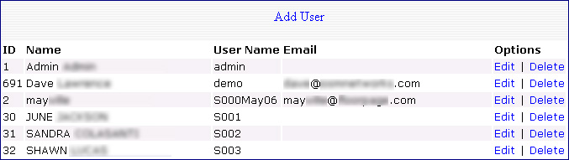

6.4 Security User Options

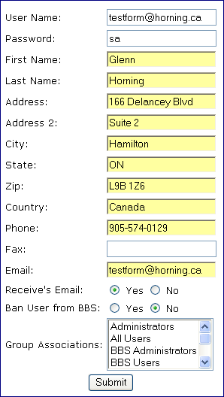
6.4.1 Edit: Allows the administrator to change any information of any user, including the Secure Groups they belong to. You can also view peoples’ passwords and change them from here.

NOTE: Since this Option shows you personal information about specific users, carefully consider who will have access to this screen when assigning the privileges of Secure Groups (point 6.2.1)


7.0 Manage Files Module

7.1 Categories of Files

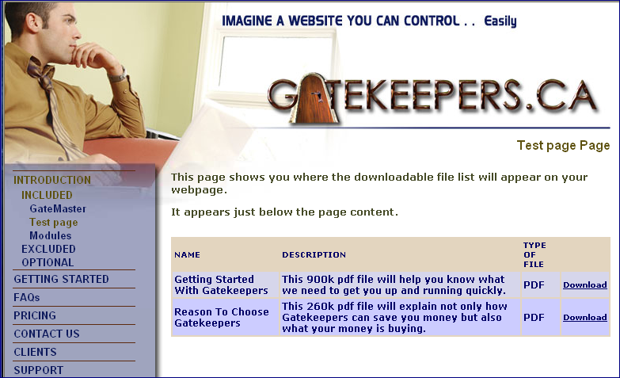
This module allows you to provide your visitors with a list of files they can download from any page you wish. The download list they will see appears at the bottom of the page you assign the files to.

You can use files from any category to appear on any page which can look like the following list as it appears on our OSMNetworks.com website.
7a
7b

7.1.1 Add File Category: Before you can upload files you must first create a category (like a folder) for the files to go into. We recommend you give each category a name that will make sense to both you and your visitors (7a). You may want to categorize your files into the types of files they are such as “pdf”, “doc”, “mp3”. Or you may want to categorize them into essential purposes your organization uses such as “new clients”, “warranties”, “private”, etc. We suggest you keep the category name brief.
7.1.2 List File Categories: You can then view, edit, and delete your category names.

7.2 Add File Options

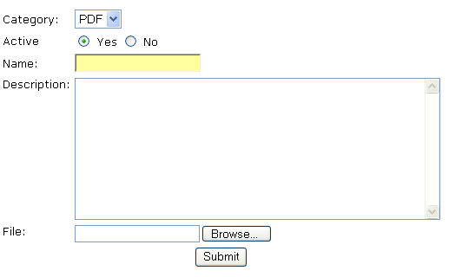
7.2.1 Add File: Allows you to upload and manage each file you want to provide your visitors.
7c

Category: Assign the category folder where the file will be stored.

Name: Give your file a short but descriptive name (7c) that you can refer to later in a webpage or when speaking to people.

Description: (7b) Add whatever comments are helpful for your visitor to understand what it is they are downloading. You may want to include further instructions for using the file. Keep your description as brief as possible.

File: Browse your computer or network to find the file. The actual filename will be changed to a unique number when uploaded.

Submit: Once you click submit you may have to wait a few minutes for the file to upload especially if it is a large file.

NOTE: Do NOT click the Submit button more than once unless nothing has happened for several minutes. If you have uploaded a large file, the submission may take a long time to complete. To see the status of the upload make sure your browser’s View > Status Bar feature is turned “on”.

7.2.2 List Files: Once the file is uploaded you can see it in the list of files. The actual file name will not be the same as it was on your computer; instead it will be changed to a number. The reason for this is if you uploaded two files with the same name, the system would cause an error. This is why it is important to name your files (7c). You can tell your visitors they can rename the file upon downloading.
7dc
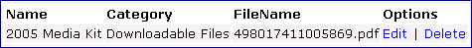

Edit: You can edit the information you included when uploading the file. Although the file name will not appear in the browse field (7d), it will still be associated to the information you are changing.

7.3 Inserting Files Into Webpages

This is very easy to do because every page will show you what files you have available. Near the bottom of any “Normal” page you will see the list of downloadable files as shown below. Holding down the CTRL key while left clicking any file name will automatically insert the file into the bottom of your webpage (item 7.1).

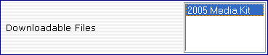

8.0 Staff List Module

8.1 Add Staff

This module allows you to make a list of staff members including names, positions, descriptions and picture of staff. Click on the add button and you will be asked to insert the staff member’s information as shown below:

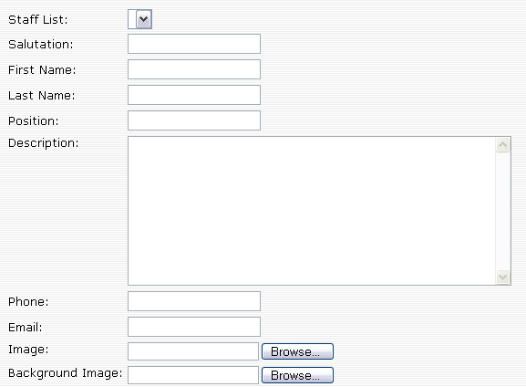

9.0 Bulletin Board Module

This module allows you to create forums or bulletin boards similar to chat rooms and blogs. A separate manual is available for this module.

10.0 Meta Tags Module
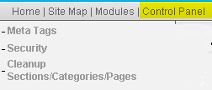
Meta Tag controls are found by clicking the ‘Control Panel’ menu item and then clicking Meta Tags.

Meta Tags are placed in the HEAD section of your HTML page which is a hidden area to most visitors yet used by Search Engine companies (Google, Lycos, Yahoo, etc.) to index your website based on your keywords and descriptions.

NOTE: META tags do not carry the weight they once did because people have cheated in the past and used them to lure people to websites that did not contain the content they were looking for. Most search engines today do not rely on Meta Tags and instead use your overall content to properly index your website. Meta Tags are now seen as a method of supporting your content when search engines are indexing them.

Here is an example of good use of Meta Tags for a Home Builder website:


